|  |  |
| --- | --- |
| Talal Al-Otaibi  Maddie McKienzie  Daniel Rafie  Jack Smith  Jack Qiao | ME 338  Prof. M. Tehrani  Spring 2022  5/13/2022 |

**ME338 Final Report**

**Descriptions of Group’s Activities**

**Group Meetings**

We hosted group meetings in one of three spaces: ETC first floor, EER Makerspace, or on zoom. Due to our conflicting schedules, we found it easiest to be in constant communication through text and have zoom meetings with whoever was available and upload the notes afterwards. We found that we were able to be productive in this way, and followed our meeting agenda well. Splitting up responsibilities came as a first come first serve opportunity, with some people already having a lot of experience in some sections and taking charge in those. Our roles were different in each of the two sections of the project, the design and the manufacturing. For the design, we split up our roles into CAD, Calculations, Simulations, and General Design. For the manufacturing process, we were all working in the Makerspace and some of us worked in the Machine Shop as well.

**Calculations**

**Top Speed of the Car**

We wanted our top speed of our car to be relatively fast and we wanted to make it a little higher than our estimated driving speed to give us a small buffer. To find the absolute max speed possible, we assume we accelerate the car on the long part of the track (10 m long). Given the design constraint of doing 3 laps in 20 seconds, we find that the time we have on the long part of the track will be 2.67 seconds proportionally. Starting from rest and at constant acceleration, max velocity is 2*x/t = 7.6 m/s that we’ll round to 8 m/s for simplicity.

**Max Acceleration of the Car**

Assuming a static coefficient of friction to be 1, the max acceleration of the car is limited by our traction (weight) of the car. Since most of our weight is on the rear wheel drive, the max acceleration from our car is mg/(2*m) = g/2 = 4.9 m/s^2 roughly.

**Drivetrain Design** **Calculations**

Since the force output from the wheel is around 4.9 N in the last section, we get the required wheel torque by multiplying 4.9*r = 0.18 Nm since the wheel diameter is 73 mm. We decided to use a two stage gear ratio, both 3:1, resulting in a total reduction of a 9:1. So, we would need 0.18 * 9 = 7.78 mN/m torque coming from the motor. Using the torque-speed curve of the motor, we can find the operating point and get the speed, which is around 22000 rpm at this torque.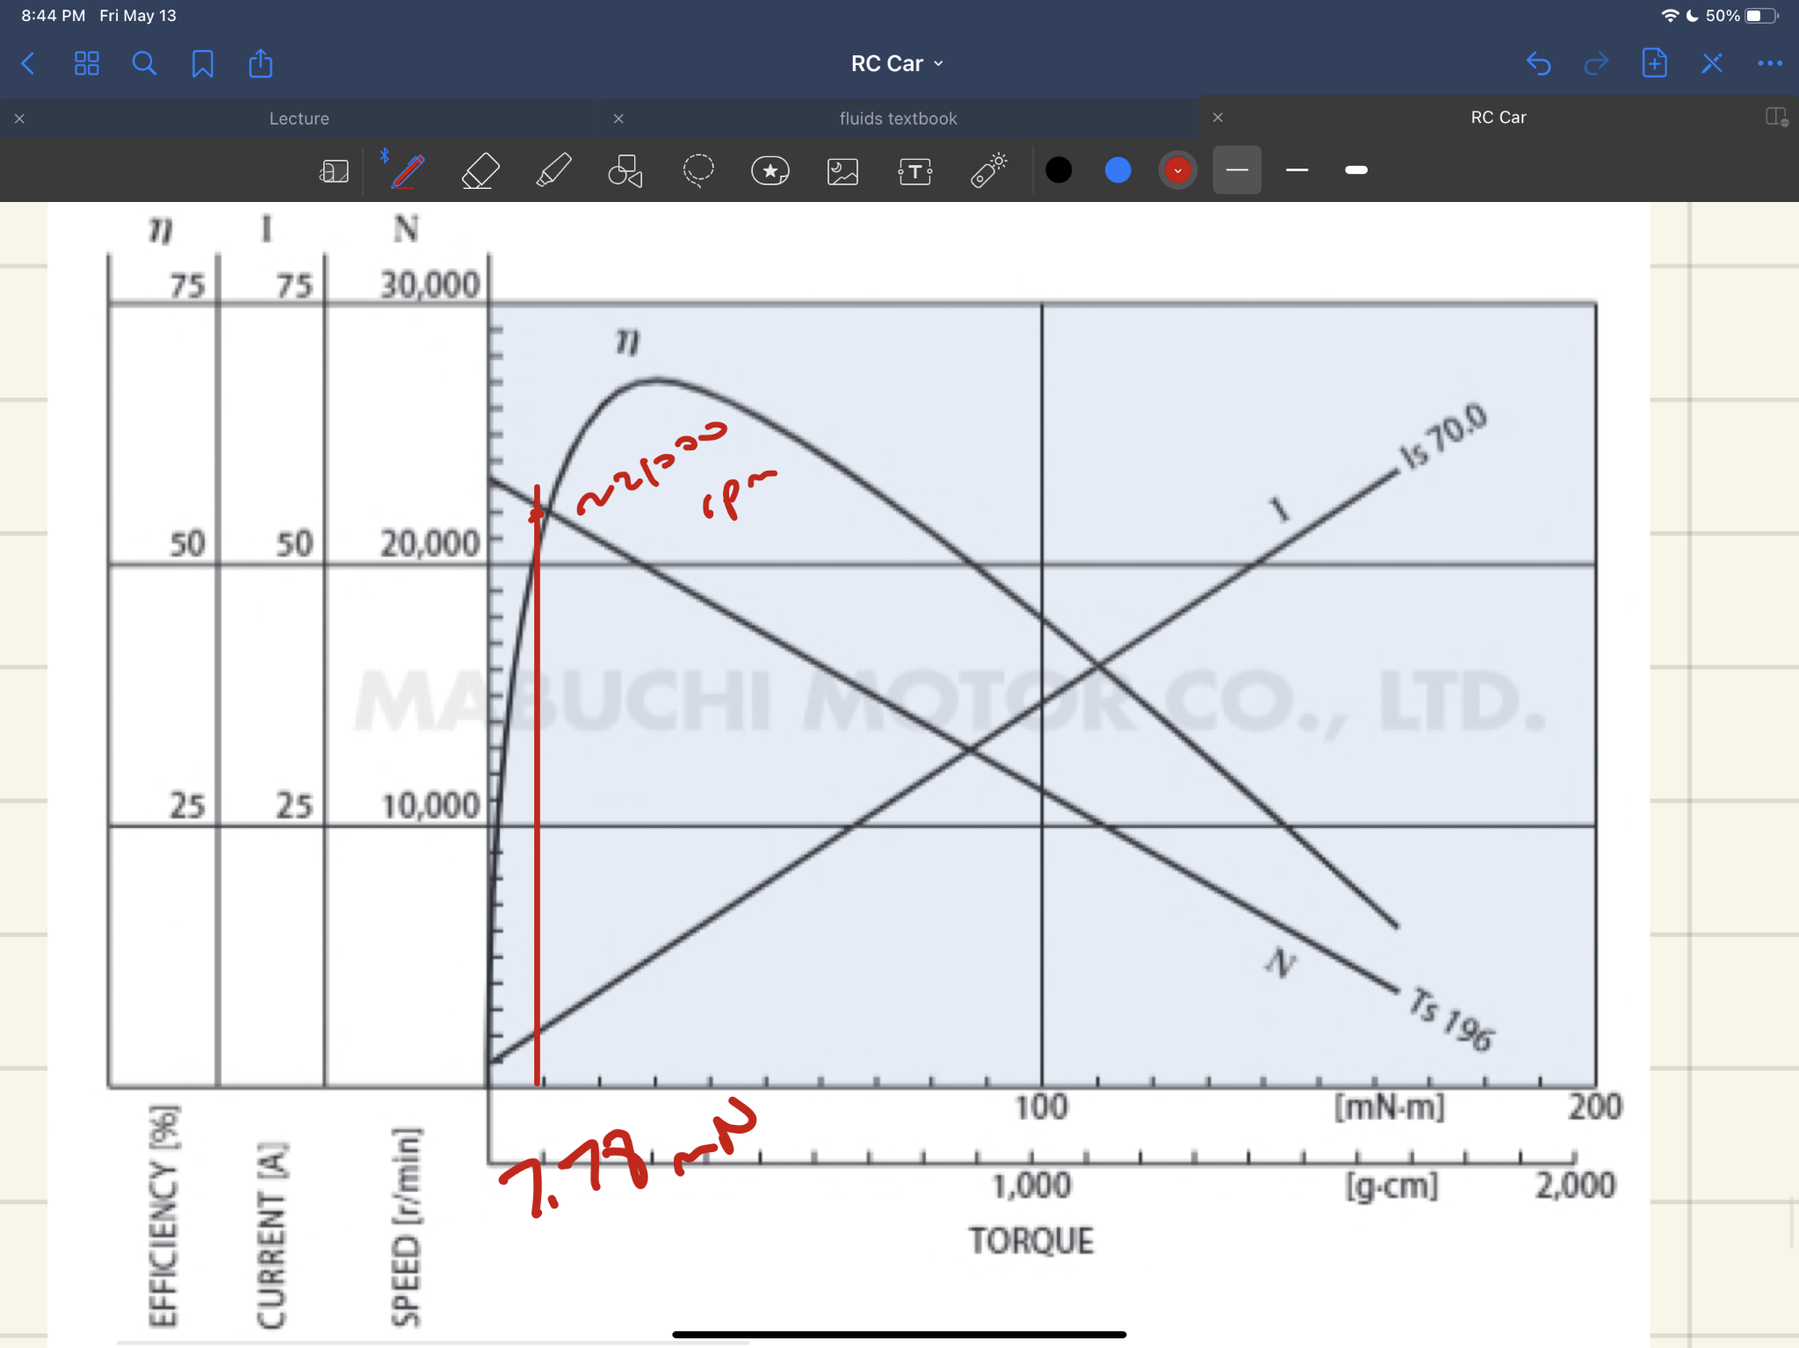

Going backwards now to the wheel, 21000 rpm * 2pi * r/(9*60) = 8.6 m/s as the speed of our car, which also approximately matches up with our max speed calculations as desired. So, we proceed with the 9:1 gear train ratio.

**Impact Forces**

We use SolidWorks to find the deflection of the axle and chassis in order to find the impact forces. Below is the deflection FEA plot of the car with 4N loaded at the front while ground the wheels.

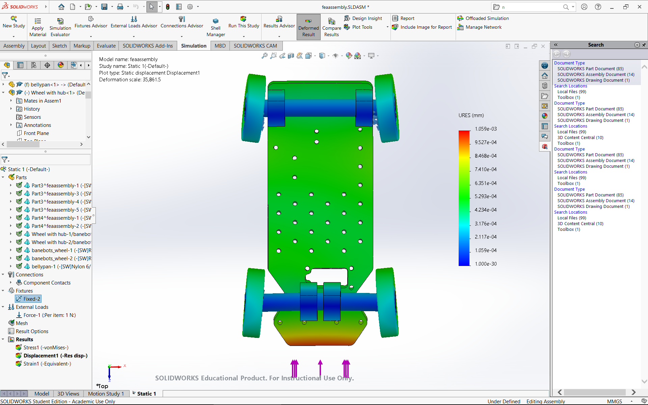

Using the previously mentioned top speed of 8 m/s, a load of 4 N is concentrated at the front of the chassis with the base of the wheels fixed. With a deflection of 9.7 x 10-8m for the axle and 6.4 x 10-7m for the chassis, the k constant of the entire car can be found. The calculated result shows the k constant to be 2.812 x 106 N/m. Finally after finding all the variables needed, the impact force came out to be , assuming m = 1 kg and 𝜂 = 1.

**Simulations of Stresses and Deflections During Impact**

As stated before, the FEA simulation involved a load of 4 N at the front of the chassis with the base of the wheels fixed. With a max velocity of 8 m/s, the deflection of the axle and chassis came out to be 9.7 x 10-8m and 6.4 x 10-7m, respectively. These deflections are acceptable as it takes a really large load, one that the car won’t experience, to deflect the chassis and axle. The 0.5” diameter axles make it really difficult for it to deflect a significant amount. The impact stresses going at max speed came out to be 34.45 MPa for the chassis and 504 MPa for the axle. Ultimately, using Von Mises, the safety factor for the chassis came to be a reasonable value of 2.03, but the safety factor for the axle is 0.478, a failing value. This is fine for the design for now since such high impact forces can cause failure, and we used a very conservative model.

**Steering Mechanism Design**

Our steering mechanism consists of each of the front wheels being mounted to the knuckle which is attached to the servo with a tie rod. Because there are two tie rods, we created a 3D printed piece that mounts onto the servo and then each of the tie rods mounts onto the piece. To mount the tie rods, we used M3 bolts and heat set inserts in the 3D printed servo adapter and the knuckles.

To calculate our steering geometry, we first had to determine our track and wheelbase, the driving dimensions of our chassis. The track is the distance between the center of the two front wheels and the wheelbase is the distance between the center of the front and back wheels. We wanted to get as close to the golden ratio of 1.75 for wheelbase/track. The second parameter was to ensure we could fit all of our electronics. We wanted to keep our car small and fast so we set our track to 6” and our wheelbase to 10”. This gave us a ratio of 1.66 which would allow our car to turn similar to a kit RC car.

The next step was to design the knuckle to determine the distance between the knuckle’s axis of rotation and the center of the wheel. The wheel has a hub with a hex profile. The shaft is attached to the hub using a set screw and passed through a bearing in a 3D printed housing known as the knuckle. Inside the knuckle there is a lip for the bearing to be captured in one direction. To capture the other direction, we tapped the end of the shaft and used a bolt and washer to prevent the shaft from pulling out of the bearing.

Once we determined this distance was 1.16”, we could set up our steering geometry schematic. We connected perpendicular lines to the wheels and a line from the rear axle. The intersection of this point is the center of our turn radius. With our geometry, our turning angle was 31° for the left wheel and 34° for the right wheel. The final step was to determine the mounting point for the tie rod and the location of the servo. We wanted the servo to be behind the front axle to protect the steering linkage from any impact. Our mounting point for the tie rod was along the line that connects the center of the rear axle to the knuckle axis, as dictated by Ackermann Steering Geometry. The tie rods were then attached to these mounting points on the knuckle and to the 3D printed piece on the servo. As the servo rotated one direction, it pulled one wheel in and pushed the other out, effectively turning the car.

**Joint Design**

Our car assembly was broken down into a couple sections: The belly pans, the rear module, the gearbox, the front knuckle module, and the steering module. Each of the individual modules had 3D printed housings with heat set inserts in the top and bottom. All of the modules were then attached to the belly pans using bolts through the heat set inserts. This method allowed us to assemble and test each module individually and then attach them to the belly pans. The car was also very rigid because each of the internal components was sandwiched between two belly pans. Our original design used ⅛” aluminum plates for the belly pans but due to the resources available to us, we used ¼” plywood that we cut on the laser cutter.

**Description of Car Manufacturing**

This joint design was very effective for being able to create and assemble each module individually. Because each of the modules were mounted in two places on the top and bottom, they were completely sandwiched between the belly pans and fully rigid. Using 3D printing housing with heat set inserts allowed us to design pieces that fit our bearings and had precise center to center distances and tolerances. While this method was very easy to assemble, because all the modules were mounted onto the same plate, we had to fully remove the top belly pan every time we needed to perform maintenance on the car. We also had to manufacture our shafts from a stock shaft. Our design required three different shafts: two were the axles and one was machined into a stepped shaft. Each of these shafts were tapped on both ends so that we could secure them to our chassis. The stepped shaft was made using an iterative process - we shaved it thinner over eight passes so that we could achieve a precise diameter that fit perfectly into one of the 12T pinions. If we were to redesign the car, we would change the mounting arrangement so that the front modules with the steering module were separate from the rear module.

To manufacture the car, we first laser cut our belly pans and began 3D printing all of our components. Since we had a lot of pieces to print, it was important that we started the process early. Before 3D printed our final pieces, we printed a small test piece with different sized holes to test the tolerance of the specific printer. We then adjusted the values in our CAD before 3D printing. Once the components were printed, we then installed all of the heat set inserts into the prints. The next step was to machine the shafts, which was detailed previously. Once we had our components ready, the next step was to assemble. We first assembled each of the knuckles as they are their own separate module. Next, we mounted all of the 3D printed pieces to the belly pan using 8-32 bolts. We installed the rear axle by inserting the shaft and used the retaining rings to capture the wheels and shaft. While inserting this shaft, we installed the 36T pulley and it’s belt. We then installed the secondary shaft, the motor and the first stage belt. For the front module, we assembled the servo first. We attached the servo horn with the connected adapter to the belly pan. Then, we used M3 bolts to attach the tie rod to the knuckles and the adapter. We then mounted the knuckle through its rotation point. Once the mechanisms were mounted, we used velcro and zip ties to attach our electronics. The top belly pan was then laid on the top and mounted to the internal components and standoffs using 8-32 bolts.

**Reflections**

**Analysis of Car Performance at Race**

Overall, our car performed with the calculated metrics. Unfortunately we ran into two main issues during the race. The first was that the bolts holding our wheels to their shaft came loose and one of our wheels came off during the race. This had an easy fix which was using Loctite to secure the bolts in the tapped shaft. The second issue was a larger problem that we could unfortunately not easily fix. Our gearbox consisted of two stages, a 12T pinion on the motor to a shaft that had a 36T pulley and another 12T pinion. The second 12T pinion was connected to another 36T pulley on the rear axle. The second 12T pinion was attached to its shaft using epoxy as we could not create a hex profile in the pulley since it was so small. Unfortunately the adhesive broke free after testing the car for a while and resulted in the rear axle not receiving any power. In order to fix this problem, we would have had to have either modified the gearbox design, welded the pulley onto the shaft (they are both made of aluminum), or used a set screw to secure the pulley on the shaft.

Overall, the design of our car was very effective. We had a proper turn radius and steering mechanism to easily turn around the corner of the track. If we were to change anything, we would have liked to include a differential to allow us to make sharper and more precise turns. Another improvement would be to use smaller shafts, as ours were definitely larger than necessary, and use 3D printed gears instead of belts and pulleys. This would have allowed us to machine our gearbox components ourselves and have a stronger interfacing between the gears and the shaft. This would have solved our problem that we experienced during the race with our pinion becoming loose from its shaft.